Sept. 11 Photographic History Collection Acquisitions, 2011 - 2021

Between 2011 and 2021, the Museum has added over 160 photographs to its Photographic History Collection. The photographs include Nina Berman, Ashley Gilbertson, Marco Grob, and Joanne Leonard, and Jo Tartt.

- New York City-based photojournalist, filmmaker, and professor, Nina Berman’s 55 color photographs, 36 x 36-inches, sample three bodies of work previously published in magazines and books: Homeland (September 2001 to 2008), Marine Wedding of Marine Sgt. Tyler Ziegler and Renee Kline (2006, 2008), and Purple Hearts (2003-2004). Images not available digitally at this time.

- A limited-edition portfolio, 3/3, by Ashley Gilbertson includes fourteen-14 X 24-inch gelatin silver prints in which the photographer has handwritten a description of the fallen young solider on the print. The photographs are from a book project, Bedrooms of the Fallen. Gilbertson, a member of VII Photo Agency, is frequently published in the The New York Times and other media platforms.
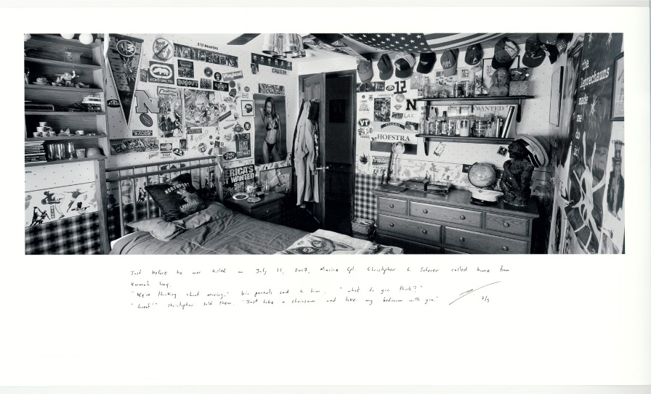
Bedroom of Marine Cpl. Christopher Scherer by Ashley Gilbertson

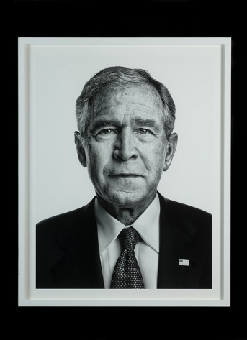
- Swiss photographer Marco Grob’s seventeen, oversized and framed gelatin silver prints were commissioned by TIME magazine for his series, “Beyond 9/11: Portraits of Resilience, to honor the 10th anniversary of September 11, 2001.” Among the sitters are activist Cindy Sheehan; now-Senator Tammy Duckworth; Former US Defense Secretary Paul Wolfowitz; flight attendant Cristiana Jones, who is associated with the shoe-bomber flight; Ali Abbas, who was a victim of misdirected allied bombing in Baghdad; US Army Chaplin James Yee ministered to Muslim detainees at Guantanamo Bay detention camp; and the artists Paul Myoda and Julian Laverdiere, two of the artists who designed Tribute.

President George W. Bush by Marco Grob
- During his military service as an aerial gunner in Afghanistan from March 2013 to June 2013, Ed Drew produced tintypes. Ten of his photographs are portraits of his fellow Combat Rescue crew members.
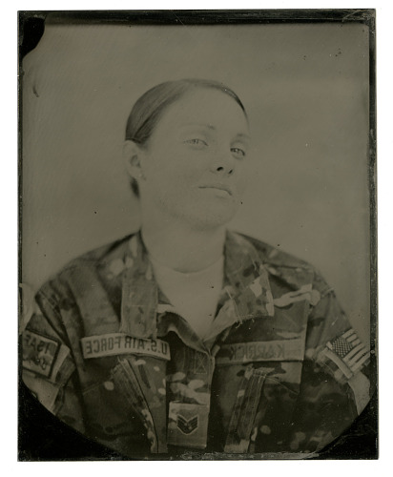
Female U.S. solider by Ed Drew

- Photographer and professor-emeritus at University of Michigan, Ann Arbor, Joanne Leonard clipped newspaper photographs and paired them classical paintings, famous photographs, and other images found in book publications in her series Newspaper Diary. Among the 129 -24 x 36-inch color are seventeen related to images of the middle East clipped from the New York Times and newspapers (2006, 2009, 2010-2015, 2018). Images not available digitally at this time.

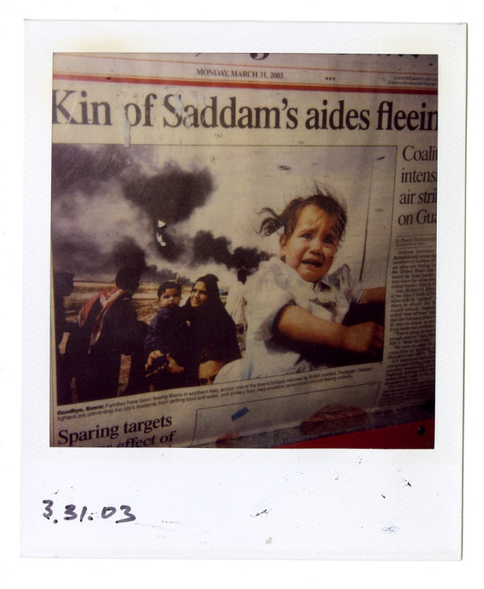
- Jo Tartt, photographer and former DC-based gallery owner, documented newspaper headlines, often in newspaper boxes in 49 Polaroid instant camera photographs, between March 19, 2003 as the US prepared to declare war on Iraq and the capture of Saddam Hussein in December 2003.

Kin of Saddam’s aides fleeing by Jo Tartt

